The Q Coffee Empire

MA0276773-D

TMSME,

8TH NORTH,

MENARA TM,

50672, JALAN PANTAI BAHARU KUALA LUMPUR.

**21th March 2022**

To whom it may concern,

**LETTER TO AUTHORIZE PERSON IN CHARGE**

We the undersigned, hereby authorize **SITI HAZAR BINTI MOHD FAUZI RUMANUS** with NRIC number **930402-01-5434 / NANEE AMYSHA CHU** with NRIC number **000712-12-2090** to acton our behalfin manners relating to application for authorization, including signing of all services relating to the account with Unifi.

Enclosed are the copies of Company SSM form which are required to complete the registration process.

Sincerely,

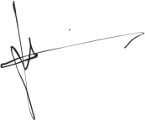

Director Name:

Muhammad Rafiqin Bin Mohd Rafiee Louis

NRIC: 890115-59-5313