TMSME, 8TH NORTH,

MENARA TM,

50672, JALAN PANTAI BAHARU KUALA LUMPUR.

**21th March 2022**

To whom it may concern,

**LETTER TO AUTHORIZE PERSON IN CHARGE**

We the undersigned, hereby authorize **SITI HAZAR BINTI MOHD FAUZI RUMANUS** with NRIC number **930402-01-5434 / NANEE AMYSHA CHU** with NRIC number **000712-12-2090** to acton our behalfin manners relating to application for authorization, including signing of all services relating to the account with Unifi.

Sincerely,

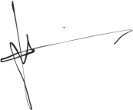

Name: Wan Muhammad Waiz Bin Wan Ramlan

IC : 990820-10-5875