ALBA POLYESTERS

JM0631575-M

TMSME, 8TH NORTH,

MENARA TM,

50672, JALAN PANTAI BAHARU KUALA LUMPUR.

**07th February 2022**

To whom it may concern,

**LETTER TO AUTHORIZE PERSON IN CHARGE**

We the undersigned, hereby authorize SITI HAZAR BINTI MOHD FAUZI RUMANUS with NRIC number 930402-01-5434 to act on our behalf in manners relating to application for authorization, including signing of all services relating to the account with Unifi

Enclosed are the copies of Company SSM form which are required to complete the registration process.

Sincerely,

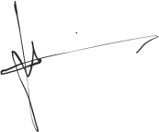

Director Name:

LIM KAM HWA

NRIC: 671128-08-5777