.

TMSME,

8TH NORTH,

MENARA TM,

50672, JALAN PANTAI BAHARU

KUALA LUMPUR.

**1ST December 2021**

To whom it may concern,

**LETTER TO AUTHORIZE PERSON IN CHARGE**

We the undersigned, hereby authorize Leong Choong Lan with NRIC number 620409-10-6378 to acton our behalfin manners relating to application for authorization, including signing of all services relating to the account with Unifi

Enclosed are the copies of Company SSM form which are required to complete the registration process.



Sincerely,

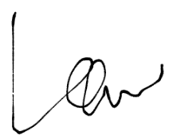

______________________

Director’s name: LAW KAM TUCK

IC/Passport: 610828-06-5671