BULL TECH SOLUTION

JR0127486-M

TMSME, 8TH NORTH,

MENARA TM,

50672, JALAN PANTAI BAHARU KUALA LUMPUR.

**26th October 2021**

To whom it may concern,

**LETTER TO AUTHORIZE PERSON IN CHARGE**

We the undersigned, hereby authorize Leong Choong Lan with NRIC number 620409-10-6378 to act on our behalf in manners relating to application for authorization, including signing of all services relating to the account with Unifi

Enclosed are the copies of Company SSM form which are required to complete the registration process.

Sincerely,

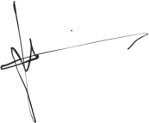

Director Name: LAM WENG SOON

NRIC: 930529-10-5445